Researcher digital experience insights survey 2021/22
UK higher education (HE) survey findings
Jisc data analytics

This data is shared under Creative Commons licence: CC BY-NC-SA 4.0
Attribution-NonCommercial-ShareAlike

Contents
Introduction 3
Survey findings 4
Theme one: you and your technology 5
Theme two: technology at your organisation 6
Theme three: technology in your research role 8
Theme four: developing your digital skills 12
Get involved 14
Supporting you 14

References
www.hesa.ac.uk/support/providers (who submitted a student return to HESA in 2020/21)

² ⁺ ³ National data from HESA 2020/21 using HEIDI+ based on full person equivalent (FPE). Data is defined as: HESA staff (excluding atypical) FPE - academic year 2020/21, academic employment function – research only. For PhD researchers the count was based on HESA student 2021/22 FPE, level of study – higher degree (research)
National data from HESA 2020/21 using HEIDI+ based on full person equivalent (FPE). Data is defined as: HESA staff (excluding atypical) FPE - academic year 2020/21, academic employment function – research only. For PhD researchers the count was based on HESA student 2021/22 FPE, level of study – higher degree (research)
⁴ Topic model - Wikipedia
⁵ Gallagher, R. J., Reing, K., Kale, D., and Ver Steeg, G. "Anchored Correlation Explanation: Topic Modeling with Minimal Domain Knowledge." Transactions of the Association for Computational Linguistics (TACL), 2017.

Jisc data analytics
0333 015 1165
help@jisc.ac.uk
digitalinsights.jisc.ac.uk
Twitter: @JiscAnalytics
Jisc
4 Portwall Lane
Bristol
BS1 6NB
0203 697 5800

Introduction

About digital experience insights
Our digital experience insights surveys show participating organisations how students, staff and researchers are using technology, what is making a difference and where improvements can be made. The surveys deliver valuable data to inform digital strategy, investment plans and to help responses to changing environments and priorities. We offer surveys for students, teaching staff, professional service staff and researchers. This report presents the findings from the 2021/22 survey of researchers.

Scale of response
The digital experience HE researcher survey ran between October 2021 and July 2022. In total, nine organisations took part: four of these were based in England, four in Scotland and one in Wales.
This year 849 researchers responded to the survey. The highest response rate from a single HE organisation was 240 researchers (6% of their total researcher population) and the overall average response rate was 94 responses per organisation (on average, around 29% of the researcher population in each organisation).

Is our sample representative?
The nine organisations who participated in this survey represent 3% of all HE organisations in the UK¹ so this is a small sample.
By comparing this to data from the Higher Education Statistics Agency (HESA) we have determined that the digital experience insights survey for 2021/22 underrepresents researchers from organisations based in England and Wales, compared to the UK researcher population as a whole. However, it overrepresents researchers from organisations based in Scotland when compared to the UK researcher population.² Note that no organisations from Northern Ireland participated in the survey this year.
The breakdown by gender slightly overrepresents females compared to the UK researcher population as a whole when compared with HESA data³.

Uses and limitations of this data
The data is not weighted to match the national researcher population (eg by gender) and therefore, we advise against comparing at the level of individual percentage points across the years, especially as the questions and answer options have changed slightly between the years.
Additionally, different organisations have taken part in the survey year-on-year, so we advise against making direct comparisons across the years even when the question wording is exactly the same.
Percentages in this report may have totals that do not add up to 100%. This is due to rounding or where participants can select more than one answer.

Methodology

The question set
The core question set contained 28 main questions: 24 closed questions and four were open-ended qualitative questions. The 24 closed questions often had sub-questions, bringing the total number of individual questions to a maximum of 39. All questions were optional.
Most questions were standardised across all insights surveys to enable benchmark comparisons. One page was customisable so that organisations could add additional questions pertinent to their local needs. All relevant closed questions had a non-response rate of 2.9% or less (with an average 1% non-response rate).

Methodology for the qualitative open-ended questions
All qualitative open-ended questions were analysed using semi-supervised topic modelling⁴, a form of Natural Language Processing (NLP). This used the CorEx algorithm⁵, implemented in Python, using “anchor terms” developed with domain experts in Jisc to steer the model towards creating the most useful set of topics for classifying responses. This tended to create more meaningful and less heterogeneous topics than purely unsupervised approaches, such as Latent Dirichlet Allocation (LDA).
The algorithm then classified the responses from the survey according to the topics in the model, and this could be used to interpret the answers to the question. For example, by looking at the breakdown of responses by topic, and their relationship to other characteristics of respondents and other questions in the survey. The analysts developed narratives based on this analysis, using visualisation tools such as Tableau or PowerBI.

Survey findings

The survey covers four key themes:
- Theme one: you and your technology
- Theme two: technology at your organisation
- Theme three: technology in your research role
- Theme four: developing your digital skills
This report outlines the survey findings in each theme in turn with additional demographic information provided below.

Demographic information
Demographic data from 849 respondents was collected to help understand the profile of researchers who responded to the survey.

Q1. How many years have you worked here as a researcher? (select one option)
- 20% less than a year
- 34% 1-3 years
- 25% 4-9 years
- 21% 10 years or more

Q2. Which of these best describes you? (select one option)
- 47% R1: first stage researcher (up to PhD)
- 25% R2: recognised researcher (post-doc or equivalent, not fully independent)
- 12% R3: established researcher (fully independent)
- 17% R4: leading researcher (including PIs and team leaders)

Q3. How old are you? (select one option)
- 1% 21 or under
- 5% 22 to 24
- 19% 25 to 29
- 68% 30 to 59
- 6% 60 and older

Q4. What gender do you identify as? (select one option)
- 54% female
- 44% male
- 2% other eg non binary

Q5. How would you describe your ethnicity? (select one option)
- 71% White
- 4% mixed ethnicity
- 3% Black African, Caribbean or Black British
- 15% Asian or Asian British
- 7% other ethnic group

Q6. Do you identify as being disabled or as having an additional support requirement? (select one option)
- 11% yes
- 89% no

Q28. Which of the following best describes the area of research in which you work? (select one option)
- 26% health sciences: associated with medicine
- 10% natural sciences
- 25% maths, physics, engineering and technology
- 16% social sciences
- 17% arts, humanities and languages
- 1% design and creative arts, including media
- 3% professional: law, business, education etc
- 3% Other

Theme one: you and your technology
In theme one we established which devices and technologies researchers used in their work and whether they had any additional support requirements.

Q7. Which of these devices do you regularly use for research work? (tick all that apply)
- 94% laptop
- 52% desktop computer
- 45% additional screen
- 44% smartphone
- 30% additional mic or headset
- 23% additional camera or webcam
- 19% tablet
- 0% none of these
Laptops were the most cited devices used, but just over half of respondents also used a desktop computer. Additional screen usage was the next most cited device, closely followed by smartphones. Use of additional microphones, headsets, cameras or webcams was less likely.

Q7a Have we given or loaned you and of these devices, or helped you to buy them? (select one option)
- 60% yes
- 40% no
Note that this question was only asked of those that said they had used at least one of the devices listed in question 7.
“Provide hardware that meets the demands of each researcher on an individual basis, not dependent on their school.”
“Provide discounted laptops/PCs for students."

Q8. Do you use any of these features? (tick all that apply)
- 22% spelling or writing support
- 18% captions or transcripts on video
- 11% alternative or ergonomic devices
- 9% dictation: speech to text
- 8% screen reader: text to speech
- 6% screen magnification
- 57% none of these
Less than half of respondents were using tools designed to aid accessibility and improve productivity, possibly indicating perhaps that they may be unaware of the benefits of doing so.

Q8a. Have we provided any support to use these features? (select one option)
- 19% yes
- 81% no
Note that this question was only asked of those that said they had used at least one of the devices listed in question 8.
“The ability to work from home in the same way as in the office has been great. Video teleconferencing has revolutionised how we work.”
“It would be good to have a better explanation of the IT structures eg for data storage, the difference between default file saving to various drives and OneDrive – and get rid of the message about the Home Directory being close to capacity!”

Theme two: technology at your organisation
In theme two, we looked at the perceptions of researchers in terms of the quality of the online working environment, how well they were supported to access it off campus, and communication online. We also looked at the apps that they found useful in their research and at their preferences for future investment.

Q9. Which of these do we provide to support your research? (tick all that apply)
- 95% video platform for live meetings (eg Zoom, MS Teams, Google Meet)
- 33% collaborative applications (eg Google Docs, virtual boards, wikis)
- 21% high performance computing
- 18% virtual research environment
- 3% none of these
The majority of respondents had access to video platforms for live meetings, but only a third said they had access to collaborative applications – slightly at odds with the fact that video platforms can be used for collaboration purposes. Only just over a fifth had access to high performance computing and fewer had access to a virtual research environment.
“I can do more or less everything that I need to do online and access the systems I need so it doesn’t matter whether I am in my office or at home.”

Q10. How much do you agree that …? (agree/neutral/disagree)
The percentages of researchers who agreed they were supported in using systems and services at their organisation and communicated with effectively online were:
- 58% support you to access online platforms and services off site (30% neutral, 12% disagree)
- 51% communicate effectively online eg messaging, notifications (36% neutral, 14% disagree)
- 39% support you to use your own devices (41% neutral, 20% disagree)
- 16% give you the chance to be involved in decisions about research platforms (45% neutral, 39% disagree)
Agreement with these statements was fairly modest indicating scope for improvement. Disagreement was highest in relation to feeling supported to use their own devices and not feeling involved in decisions about research platforms. Engaging researchers in discussions about their digital experiences will provide valuable insight and benefit both the organisation and researchers.

Q11. Please give an example of a digital tool or app you find really useful for research (open-ended, free text)
Researchers were asked to give an example of a digital tool or app that they found really useful in their work. There were 569 responses to this question and the top 25 tools or apps cited were:

- 16% Microsoft Teams
- 12% Zoom
- 5% EndNote
- 5% Mendeley
- 5% NVivo
- 4% Microsoft OneDrive
- 4% Grammarly
- 3% Zotero
- 3% Microsoft OneNote
- 2% MatLab
- 2% Nusearch
- 2% Microsoft Office
- 2% Google Scholar
- 2% Overleaf
- 2% SPSS
- 2% Google general
- 2% Google Docs
- 1% Covidence
- 1% RStatistics
- 1% Notion
- 1% Microsoft Excel
- 1% Padlet
- 1% Redcap
- 1% Microsoft Word
- 1% Gitlab

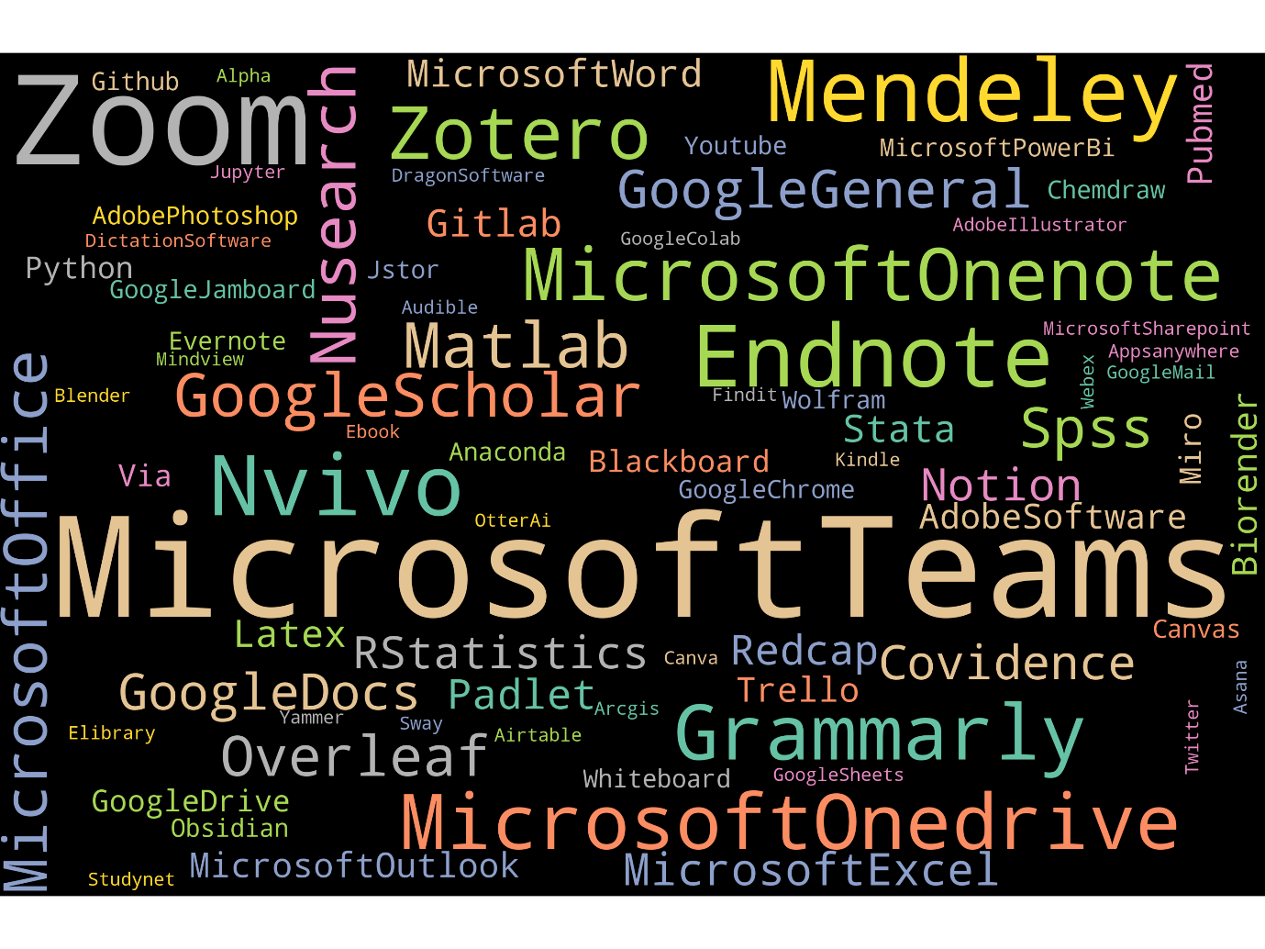
Q12. Overall, how would you rate the quality of the online environment for research? (select one option)
69% of respondents rated the quality of the online environment for research as above average (best imaginable, excellent or good) and 11% rated it as below average (poor, awful or worst imaginable).
- 1% best imaginable
- 18% excellent
- 49% good
- 20% average
- 8% poor
- 2% awful
- 1% worst imaginable

Q13. What would you prefer us to invest in? (select one option)
Should funding be available to do so, researchers who expressed a preference for future investment were fairly evenly balanced across the options of upgrading platforms and systems, specialist software for their research area and IT support.
- 28% upgrade platforms and systems
- 28% specialist software for your research area
- 27% IT support
- 17% more computers and devices
“Provide more institutional licenses for specific software (eg Adobe Creative Suite, GraphPad etc.”
“Provide specialist software with specialist training.”

Theme three: technology in your research role
In theme three we looked at how technology was used in researcher’s roles – the range of activities they engaged in, where their work was taking place and how closely this met their preferences. We also asked researchers whether they had experienced any problems when working online.

Q14. Does your research role include any of the following responsibilities? (tick all that apply)
- 48% teach students
- 24% support the use of research systems
- 23% trial/develop technologies for research
- 36% none of these
Almost half of respondents were involved in teaching students and nearly a quarter supported the use of research systems or the trial and development of technologies for research. Over a third said none of these responsibilities applied to their role.

Q15. In the most recent semester/term, has your research taken place ..,.? (tick all that apply)
- 21% mainly on site
- 38% a mix of on site and online
- 41% mainly online
Only about a fifth of researchers were working mainly on site. The majority were conducting their research either mainly online or using a mix of on site and online.

Q16. When you are working online, where do you tend to be? (tick all that apply)
- 88% at home
- 42% on site (eg lab, office, field)
- 9% in public spaces (eg cafes)
- 0% none of these
The majority of researchers were conducting their online work at home, although a significant percentage (42%) said they did this on site.
“The ability to work from home or from the library provides a nice contrast to lab working.”
“I currently have no on site workspace so working online is necessary.”

Q22. In future, how would you prefer to carry out your research? (select one option)
Researchers expressed a strong preference for research to be carried out using a mix of on site and online in the future. The nature of the research will clearly be an influencing factor here.
- 17% mainly on site
- 68% a mix of on site and online
- 15% mainly online

Q17. Have any of these made it difficult for you to work online …? (tick all that apply)
When asked about problems encountered when working online, the percentages of researchers who experienced difficulties with these options were:
- 39% poor wifi connection
- 27% can’t access research systems you need
- 21% no suitable computer/device
- 16% no safe, private area to work
- 12% mobile data costs
- 36% none of these
64% of researchers experienced one or more problems; poor wifi connection being the most cited. Over a quarter experienced difficulties accessing the research systems they needed and over a fifth said they had no suitable computer/device. These issues represented major barriers to their work.
“Provide more spaces on campus for online meetings and presentations eg a small bookable room for an allotted time to allow online meetings without disturbing others.”
“Maintaining hybrid working as a default would probably be a good outcome. Different people work in different ways and this would allow a natural balance to be struck in the long run.”

Q18. In the last two weeks, which of these research activities have you carried out? (tick all that apply)
- 74% online discussion relevant to your research
- 55% online research/data collection
- 54% live online presentation or workshop
- 52% collaborate online (eg shared presentation/report)
- 18% run online model or simulation
- 9% virtual lab, practical or fieldwork
- 7% none of these
Online discussion was the activity conducted most frequently from this list. Over half took part in online research and data collection, live online presentations or workshops and in collaborating online. Far fewer ran online models or simulations or took part in virtual lab, practical or fieldwork.

Q19. How much do you agree that working online …? (agree/neutral/disagree)
The percentages of staff who agreed with statements about working online were:
- 80% is convenient for you (17% neutral, 3% disagree)
- 67% enables you to make good progress with your research (25% neutral, 8% disagree)
- 64% allows you to research in the ways that you prefer (28% neutral, 8% disagree)
- 31% makes you feel part of a community of researchers (35% neutral, 34% disagree)
Convenience was clearly a strong factor for researchers and high percentages also showed that researchers felt working online enabled them to make good progress with their research and to do so in ways that met their preferences. Only 31% agreed that it made them feel part of a community of researchers. The percentages who either disagreed or gave neutral responses was higher indicating an area of potential concern.
“The speed of access to material (eg downloading e-books rather than travel to campus). I live far away so remote access is helpful, better for the environment and saves money.”

Q20. What aspect of remote working, if any, is most positive for you? (open-ended, free text)

There were 579 complete responses to this question with at least a one-word answer. Researchers were positive about:
- The ability to work anywhere – researchers liked the flexibility and autonomy in not being constrained to the campus and felt that concentration improved when they were able to work away from over-crowded office spaces. They felt this led to greater efficiencies in time and use of space and that it improved productivity:
“Office spaces are very crowded and sometimes I can have a better focus working from home.”
“Efficiency in terms of time, resources and space.”
“I have more time, fewer distractions and feel more productive than working on campus.”
- Access to resources, data and events – some felt that access to literature, primary sources, classic texts and data improved and they noted increased investment in digital libraries. The portability of digital research was commented upon as well as the efficacy of digital searches:
“Increased investment in e-books and making journals available online has made it easier to search for, and find, more relevant research to support my own.”
“The speed and accessibility of resources, and the ability to search withhin texts for key words and passages far more efficiently than in print form.”
“It’s like diving into almost limitless resources, restricted only by the key words we are inputting.”
Others also felt they had access to meetings and events conducted digitally that they wouldn’t otherwise have been able to attend/be invited to:
“I can access individuals in distant locations.”
“I can attend seminars and meetings that I may not have been able to otherwise.”
“Setting up/conducting Teams meetings efficiently with people in different locations.”
- Improved collaboration and connection to colleagues – respondents said they could do more and reach wider audiences when working online and that they had enjoyed collaborating and networking online both within the UK and internationally. Being able to connect with external collaborators was valued as well as reaching wider audiences for presentations:
“Online research allows me to create, develop and share anywhere and anytime. Agile working is empowered by researching online. It is the only way forward for true collaborative and translational research.”
“I’ve been able to communicate internationally, across different time zones and long distances as well as with those who are unable to come on site.”
“The ability to interact with international collaborators and discussion fora.”
- Reduced travel and improved work-life balance – respondents commented on the positive environmental impact on reduced travel, the savings in time and cost and being able to reach more interviewees online than would have been possible in person. Other aspects mentioned included: feeling able to do more with the time saved; improved life-work balance; the flexibility, comfort and safety of working from home; finding it more accessible and working around disabilities/health conditions:
“There has been a massive reduction in travel time, expense and a positive environmental impact in conducting meetings online.”
“The reduction in commuting time which previously took upwards of 2 hours a day that I can now use to make progress.”
“It reduces the need to travel for data collection and includes participants who may find travel difficult with health conditions.”
“The flexibility to adapt to other work and private constraints.”

Q21. What aspect of remote working, if any, is most negative for you? (open-ended, free text)

There were 551 complete responses to this question with at least a one-word answer. Researchers were positive about:

Online meetings – some respondents found online meetings less effective and productive than in-person or face-to-face meetings. They felt the discussions lacked depth and they missed the spontaneous elements that can generate ideas, support collaboration and solve problems. Managing hybrid meetings in terms of people having the right space and ensuring equal opportunities to participate could be challenging:
“The discussion among people is hardly performed in depth.”
“I miss the general chat that can spark ideas and solve problems that comes from seeing people face to face, eg at the start of the meeting or in the kitchen.”
“Losing the in-person/informal elements and the traininig/networking that can be confidence-building for early career researchers.”
It’s hard to reproduce the ‘wild ideas’ and progress of in-person discussion.”
- The lack of community and social interaction – the lack of social interaction left people feeling isolated and devoid of motivation or the energy/rapport they usually got from working with others. Some felt lonely, isolated and disconnected from their networks and, for some, this triggered wellbeing issues:
“It’s very lonely. I have spent the whole of my PhD working on my own in my bedroom with very little interaction from others. My home set up is not suitable, making it harder to work.”
“There is a lack of strong bonds with fellow researchers and the wider faculty.”
Similar comments to those made in relation to online meetings were made about missing impromptu conversations and peer support:
“It hinders the collaborative nature of research and intellectual interaction with colleagues.”
“It can be isolating and doesn’t always offer the best experience given lack of access to information professionals and limiting being able to handle objects for artefact analysis.”
“It creates barriers to building relationships with both colleagues and research participants.”
Although some thought it fostered greater independence but still had mixed feelings:
“Encourages more independent work, which is not always the best solution in all cases.”
- Access to software and research facilities – concerns here ranged from wanting to have administration and elevated rights to download software (perhaps being unaware of organisational licensing and security concerns), not being able to access equipment and resources necessary for their particular field of research, or finding that library resources were limited or restricted by paywalls:
“I have difficulty accessing lab and campus-based facilities (labs, robots, PCs).”
“No administrator rights for department laptops, a lot of work we do requires elevated rights.”
“Sometimes the tools given don’t work.”
“I’m not allowed to have equipment orders delivered to my home which means a four-hour drive to collect them.”
“Discovering sources that are behind paywalls or not subscribed to by the university that would be valuable to my research.”
- Connectivity issues and lack of technical support – slow response times from IT support teams was mentioned, as well as inconsistency in connectivity and difficulty with remote connections (especially pronounced if equipment was old and slow):
“I’m an experimental scientist – the key issue here is the integration of legacy apparatus with evolving IT provision.”
“Patchy connectivity. MS Teams is a poorly designed tool not suitable for researchers.”
“The main aspect is the office PC to which I connect is old and can be slow, especially when accessed remotely.”
- Too much screen time – health concerns in spending significant periods of time in front of screens exacerbated by back-to-back meetings was mentioned by some researchers. This included: fatigue; eye strain; posture issues; stress; migraines; and low mood:
“Eye fatigue – I’m overwhelmed with the volume of online journals.”
“Too much screen time, especially in video link meetings – bad for eyes, posture, stress and mood.”
“3 hours of screen use = 4 day migraine.”
- Other concerns included finding it hard to switch off and research impinging on the home environment and financial costs:
“The blur between working and home life – it can be difficult to switch off.”
“I don’t get any support for equipment so everything has to come out of my own pocket and if anything breaks I am unable to progress my work until I can afford replacements.”
“The associated costs mount up eg wifi, electricity and heating.”

Theme four: developing your digital skills
How much support, guidance and training did researchers receive to help them develop their digital skills and to use technologies effectively to work online? In theme four, we found out more about the overall digital development support offered.

Q23. How much do you agree that we have provided …? (agree/neutral/disagree)
- 32% guidance about the digital skills needed in your research role (40% neutral, 28% disagree)
- 20% time to explore new digital tools and approaches (41% neutral, 38% disagree)
- 17% an assessment of your digital skills and training needs (38% neutral, 45% disagree)
- 9% reward and recognition for your digital skills (35% neutral, 55% disagree)
The percentages of researchers who disagreed with these statements were quite high. Less than a third of researchers said they received guidance about the digital skills they needed in their research role and less than a fifth said they had an assessment of their digital skills and training needs. Very few felt they received reward or recognition for their digital skills.

Q24. Where do you go for help with online and digital skills? (tick all that apply)
- 75% online videos and resources
- 62% colleagues
- 45% IT staff
- 34% research lead or supervisor
- 31% friends and family
- 18% research support staff
- 15% library staff
- 9% other professional staff
- 3% I don’t look for help
The majority of respondents turned to online videos and resources, many also turned to colleagues, smaller percentages turned to IT staff, their research lead/supervisor or friends and family. Few turned to library staff or other professional staff.
“Please keep (and if possible expand) the helpdesk. It’s invaluabkle to be able to talk to someone. Computer problems are so baffling if you are not a digital person and the 1:1 spoken helpline is so much appreciated.”

Q25. Which of these skills have we provided support or training for? (tick all that apply)
- 38% keeping research data secure
- 36% equality and inclusion
- 25% online research methods
- 23% basic IT skills
- 22% behaving safely and respectfully online
- 20% specialist software for your research area
- 20% digital copyright and licensing
- 18% data analysis
- 15% online publishing and peer review
- 14% contributing to open/public research
- 12% coding or scripting
- 9% creating accessible digital content
- 6% new and emerging technologies for research
- 20% none of these
The responses here all fell below 40%, including skills that have legal and safeguarding aspects. This requires further investigation by the individual organisations that took part.

Q26. Overall, how well do we support you to work effectively online? (select one option)
54% of researchers rated the overall support to work effectively online as above average (best imaginable, excellent or good), 16% rated it as below average (poor, awful or worst imaginable).
- 0% best imaginable
- 16% excellent
- 38% good
- 30% average
- 11% poor
- 4% awful
- 1% worst imaginable

And finally, we asked …

Q27. To help you work effectively online, what one thing should we do? (open-ended, free text)
There were 448 complete responses with at least a one-word answer to this question. Researchers would like their organisations to:
- Provide more IT support – this includes making it easier to contact IT support and technical training, providing 1:1 support, out of hours support and support for those using their own equipment. Researchers experienced a range of problems, and some suggested decentralised support with dedicated teams for different schools, colleges or departments and personalised support based on need rather than standard purchase/support protocols. There were also requests to provide laptops, PCs and other devices (or discounted provision) and peripherals like additional screens. Improving response times was another request:
“Make it easier to contact IT support and provide more online training.”
“Dramatically upscale the amount of online training and support for PhD students.”
“Get rid of centralised IT. Rather get dedicated IT support teams into colleges and departments.”
“Reach out to support those with their own IT or offer postgraduate researchers laptops."
“Provide better equipment – more powerful laptops, printers, headsets and screens.”
“Provide hardware that meets the demands of each researcher on an individual basis, not dependent on their school.”
“Respond in a more timely manner to requests for upgrades and assistance.”
“I still can’t find a help page to move my two-step authenticator from my old phone to my new one. If you implement new technology, at least provide guidance.”
- Software provision – respondents requested more software, more licences and that these be kept up-to-date, and more choice and autonomy in their choice of software:
“Stop interfering with our choice of hardware and software, give us freedom in what to order and where to order it from and don’t force us into restrictive software choices with locked down environments.”
- Enhance remote access – improvements to wifi on campus, eduroam and faster VPN speed would enhance remote access. In turn this will help to remove barriers to off-site access to university resources and office desktops:
“It would be good to have barrier-free remote access to university resources eg gitlab, remote desktop etc…”
- Training – respondents requested more training, including more specialist training with flexible and easy access to it as well as guidance on the use of research tools and an assessment of their development needs. Mentorship was suggested as one possible approach:
“An assessment of digital skills and training needs is a good idea.”
“Notify us of newly available resources and training.”
- Improve connections to the wider team – more bookable spaces on campus should be provided to support/maintain hybrid working:
“Ensure there are plenty of bookable spaces on campus that can be used for working online in private.”

Get involved

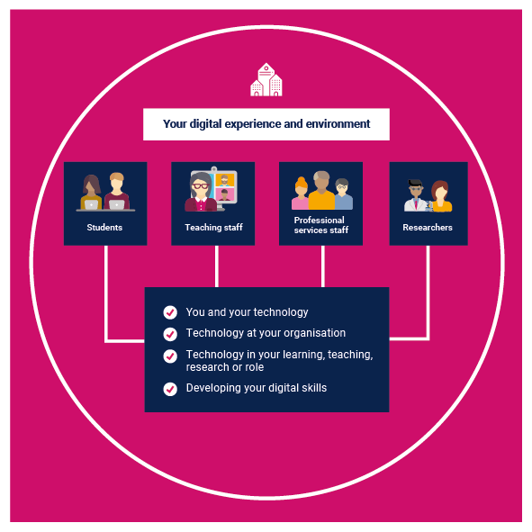
See the digital experience through the eyes of your students and staff
Our 2022/23 digital experience insights survey for researchers is now open. If you are interested in participating in our other surveys for students, teaching staff and professional services staff, please contact us at help@jisc.ac.uk putting ‘digital insights’ in the subject line.
Find out more at: digitalinsights.jisc.ac.uk

Supporting you

Higher education strategy 2021-2024: powering UK higher education
See how our HE strategy for 2021-2024 will support universities towards a technology-empowered future.

Learning and teaching reimagined
Working with you to help plot your organisation’s path to the future of higher education.
- Read the report, learning and teaching reimagined: a new dawn for higher education.
- Explore the research, visions of the future, examples of emerging good practice and tools to get you started

Digital strategies in UK higher education: making digital mainstream
- Read our review of how universities are developing and implementing digital strategies to drive forward digital transformation

Let’s work together to transform your digital experience
Contact your relationship manager: https://jisc.ac.uk/contact/your-relationship-manager

Acknowledgements
Our thanks go to the universities who took part in the researcher insights survey this year.

