Using Insights surveys in Jisc online surveys

What you need to know
This document provides information about:

Accessing your Jisc online surveys account and your chosen survey(s)
Customising your survey(s) using the Jisc online surveys design interface
Launching and distributing your survey to institutional respondents
Accessing the data collected during and after the survey is live
Visit our advice and guidance section on the digital experience insights website (digitalinsights.jisc.ac.uk/our-service/advice-and-guidance) to view our full set of guides to help you successfully use the digital experience insights service.

Accessing your survey(s)
If you choose to subscribe to the service you will receive an online ‘getting started’ form - please return this promptly, ideally within a week at the latest.
Insight surveys are created and managed in an online software tool called Jisc online surveys (previously BOS), now owned by Jisc. If you already have an institutional account with Jisc online surveys you can log in using your existing details, and you will be able to view and copy the master Insight surveys.
If you don’t already have a Jisc online surveys account, we will register you with an account once you complete the confirmation form. You will receive an email that asks you to set up a Jisc online survey username and password. Once you have done this you need to wait a maximum of 36 hours before you can view and copy the master Insight surveys on your Jisc online surveys dashboard.

If you have lost the email inviting you to create a Jisc online survey account, please go to the Jisc online surveys sign-in screen and click on the ‘lost invitation?’ link. If you want to add further users to the Insight surveys account, please email help@jisc.ac.uk to ask for new user to be added (note please put ‘insight surveys’ in the subject line of the email to ensure this is promptly directed to the right team). Once we confirm that this has been done you will need to click on the key icon next to your survey and add that person’s email address to the permissions. For any other technical enquiries please email help@jisc.ac.uk, again, putting ‘insight surveys’ in the subject line. We’ll get back to you as soon as possible and always within three working days.
You are now ready to access the insight surveys.
- If you are not already logged in, log into Jisc online surveys at www.onlinesurveys.ac.uk and click on the 'Sign in' button, top right. Sign in using the details you have set up.
Notice that at any time you have access to a ‘Help and Support’ menu (top right) with technical guidance on using the Jisc online surveys system.

- You will see your Jisc online surveys dashboard. If you already have a Jisc online surveys account, you will have to select the relevant insight survey from the drop-down menu at the top. You will also need to ensure that the box ‘JUST MY SURVEYS’ is unchecked so that you can see the master survey(s) you have requested.

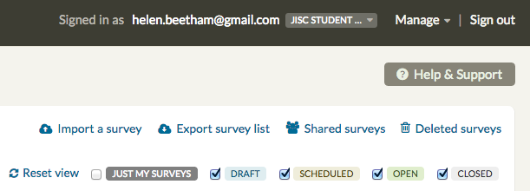

- You will see one or more MASTER insight surveys. (If you do not see the Insight surveys you have requested, please contact help@jisc.ac.uk putting ‘insights surveys’ in the subject line).
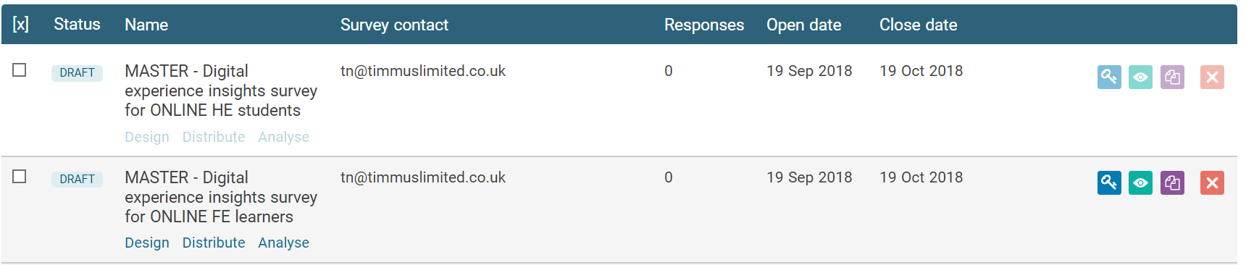

- Click on the purple ‘copy’ button to the right of each survey. When the ‘copy’ dialog box appears, rename the survey including the name of your institution in the new name. We recommend the formula: [name of your institution] [HE/FE/HE online/FE online student and/or teaching staff] [2018/19] [insight survey]. You will need to do this for each of your surveys.
If you're using the Welsh version, please indicate either by putting the title in Welsh or adding "(Welsh)" into the title.

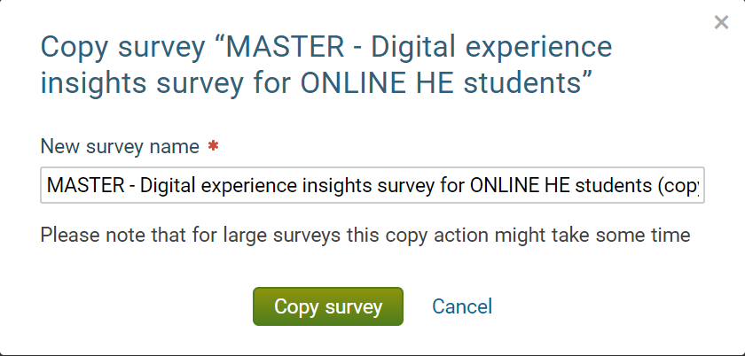

Customising your survey(s)
You should have read through and discussed our guide on Customising your Insight survey (http://bit.ly/DEIcustomise available from digitalinsights.jisc.ac.uk/our-service/advice-and-guidance) before you begin. This section tells you only how to edit and delete questions in Jisc online surveys. The customisation guide helps you decide what changes you will make and why. It is very important you have thought about these decisions before you start editing.
You will be using the pencil and cog-wheel symbols to edit, delete or copy questions.
Please DON’T MAKE ANY CHANGES other than those outlined here.
- In your Jisc online surveys dashboard, click on ‘design’ to access the relevant survey in design view. Scroll through to the first editable item (question 28 on page 12 of the student survey). Click on the pencil symbol to edit the text and change the question text (if necessary) and answer options, adding any extra answer options you require. Save your changes.
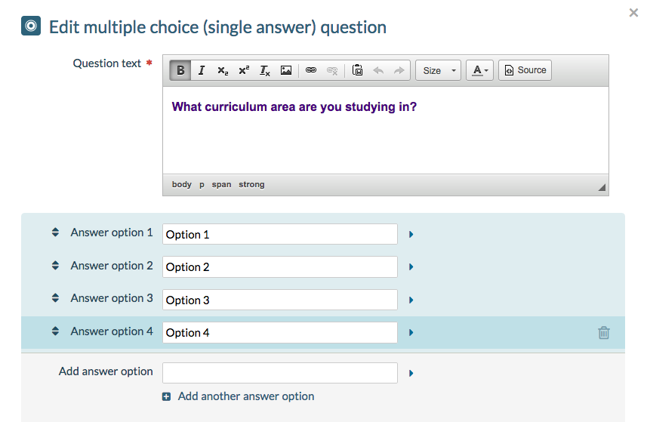

- Continue to question 27 (of the student survey) or question 20 (of the staff survey) and either edit or delete this grid question. If you are editing, the new answer options (row items) should be short, single-issue and written in respondent facing language. They should have been tested for clarity, eg by printing out the preview and asking respondents to complete the questions. Save your changes.
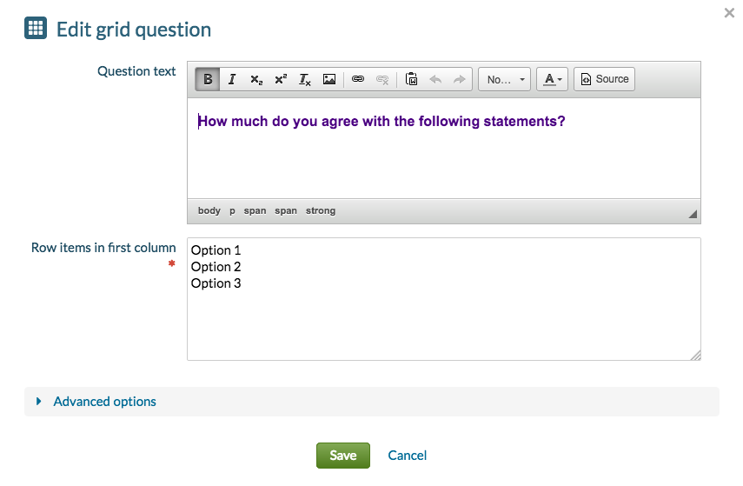
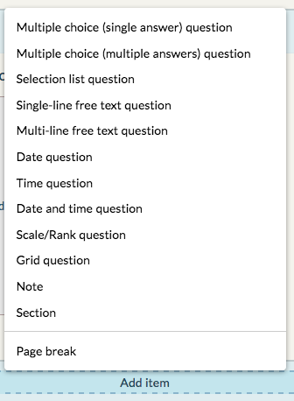
- Add any extra or alternative questions you have agreed and tested.
Please do not add any questions to the survey unless you have experience in writing respondent-facing questions and have tested them thoroughly.
Please do not introduce new question types at this point in the survey unless you are very sure what you are doing and unless you test the whole survey with a number of respondents.
Save your changes.

- Delete the entire note at the start of page 12 (of the student survey) or page 11 (of the staff survey) (in red).
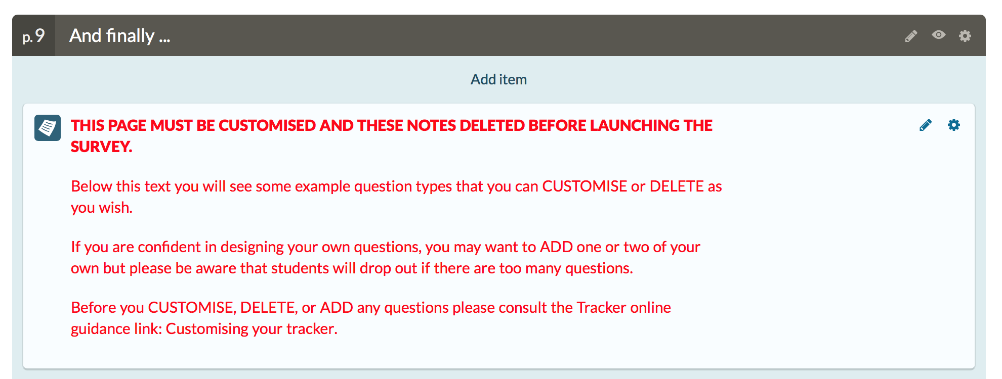

- You can also edit the ‘thank you’ text on page 13 (of the student survey) or page 12 (of the staff survey), for example to include details of how you will respond to institutional respondents’ feedback and in what timeframe. You can add in a local uniform resource locator (URL) too. Information on a potential prize draw can be added this page. This process is fully explained in our guide on customising your Insights surveys (http://bit.ly/DEIcustomise and also available at digitalinsights.jisc.ac.uk/our-service/advice-and-guidance).
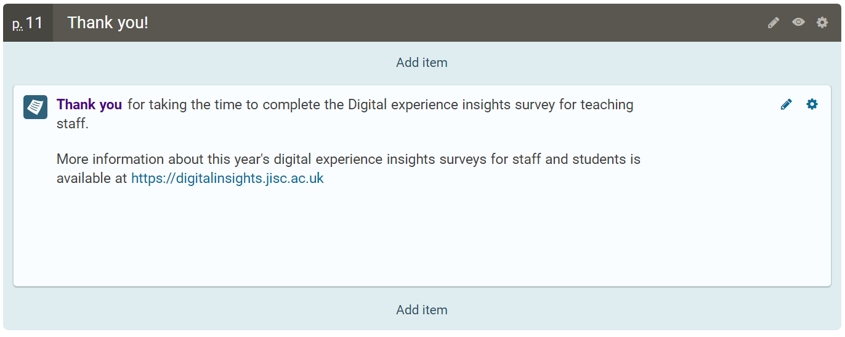
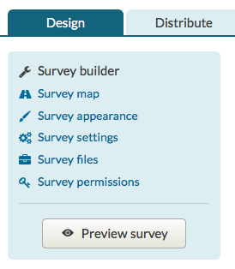
- You can now preview the survey as your institutional respondents will see it by clicking on the 'Preview survey' button in the authoring pane top left. You can do the same by clicking on the ‘eye’ icon from the main dashboard. If you want to circulate a copy of the survey for review or print one out for testing, click on the ‘cog’ icon top right within the preview screen and select ‘Export survey as PDF’.
Print as pdf to distribute
Preview in design space
Preview from dashboard vie eye icon

- If you need to make further changes, return to the 'Design' view. Remember that once the survey is launched you will not be able to make any changes, so double check everything now.
- You will need to go through the steps in this section for each survey you have ordered.

Launching and distributing your survey
Once you have launched your survey, you can’t make any further changes. So pause here and make sure you have fully tested the survey and everyone is happy with it before you proceed.
There are two ways that you can distribute the survey to institutional respondents. The first relies on you to distribute a public URL through whatever channels you think will make the most impact. The second requires you to set up an email distribution list. Jisc online surveys automatically emails each institutional respondent a unique URL to complete the survey. The latter requires more advanced use of Jisc online surveys to set up correctly, and further measures to ensure that respondent data remains anonymous.
- If you are not already logged in, log into your Jisc online surveys dashboard and locate your institutional survey(s) as before.
- Click on 'Distribute' to access the Launchpad. From the left hand blue block, select 'Distribution settings'.
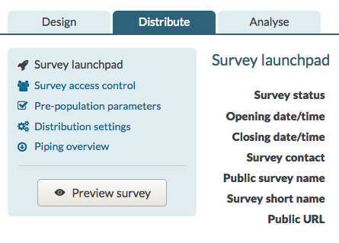
- By default, the opening time is set in the past to allow you to launch the survey whenever you want. Notice that the closing date is set to 30 April 2019 (for the student survey) and 30 June 2019 (for the staff survey). This is to allow Jisc to finalise the benchmarking process and report back on the summative data.
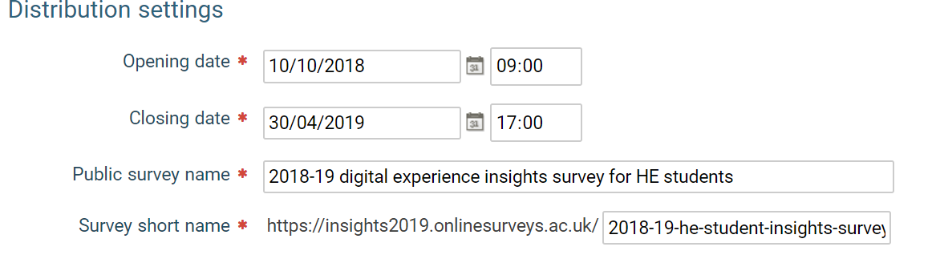
Instructions for the distribution method
- By default, the URL for distributing the survey is taken from the long survey name you used when you copied the master. You can change the 'survey short name' to create a shorter URL for sharing or use bit.ly or tinyurl to do this.
Instructions for the targeted emails method (for advanced users only)
- You will need to read through our additional guidance on uploading staff and student data into the Insight surveys (bit.ly/DEIuploaddata) . You will also need to access the help and support offered by Jisc online surveys under the tab ‘Survey Access Control’. This will enable you to:
- Create and import a CSV file of respondent email addresses, formatted as Jisc online surveys requires
- Include some test emails so you can check that everything is working
- Set options including ‘anonymous’ for institutional respondent responses
- Write an email invitation to respondents in the ‘distribute / distribution settings’ area
- Email respondents
- Continue to add new email addresses after the original upload if necessary
- Target follow-up emails at respondents who have not completed
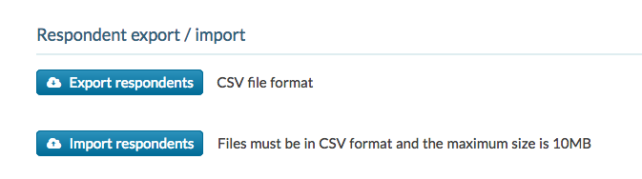
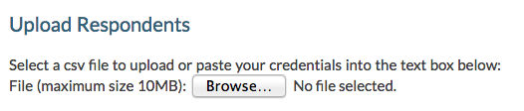
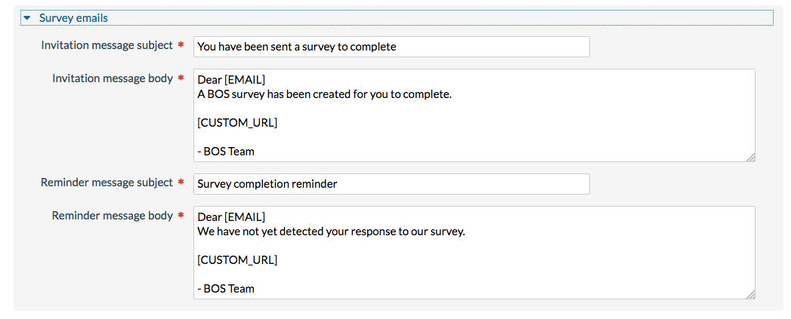
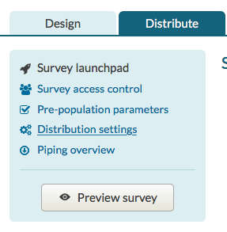
- You must remember to remove the column of respondent emails from your data before sharing or analysing it. You may want to wait until after you have allocated any prizes (if you have chosen to this).
- When you have set and saved the dates and either saved the public URL or uploaded respondent emails, click back to the survey launch pad (under 'Distribute').
- Make sure your survey is exactly as you want it, your settings are correct and your communication channels are ready to go before you click the 'Launch survey' button.
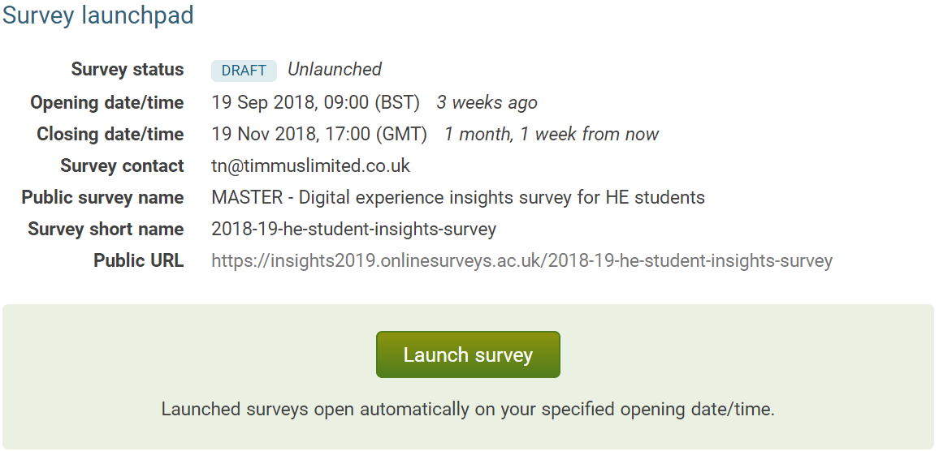
- Our guide on Engaging respondents in your Insights surveys (http://bit.ly/DEIengage and also available from digitalinsights.jisc.ac.uk/our-service/advice-and-guidance) has ideas for improving participation rates after launch.

Viewing, downloading, analysing and benchmarking your data
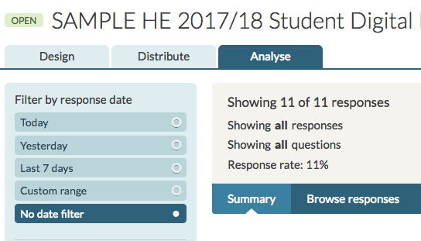
- You can access and browse your results at any time by logging on to Jisc online surveys, locating the survey, and clicking on the 'Analyse' tab. Only people with your organisational log-in details can do this (not Jisc insight or Jisc online surveys, unless you have shared your details with us).
- By default, Jisc online surveys presents you with a summary of your data in the form of a bar chart comparing percentage responses within each question. Jisc online surveys also shows you the raw score in bold and the percentage score (in brackets) for each response. With some insight questions the raw score will be more useful for analysis.
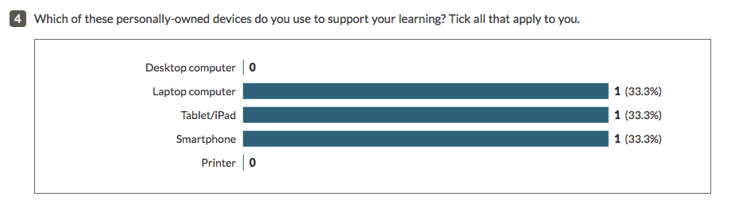
- Once you have your complete data set, you can log in at any time and download it. However, you will not have access to the full data set for benchmarking until the Insight survey closes.
You download data using the ‘Export’ button on the right at the top of your ‘Analyse’ screen. 'Download PDF' replicates the graphical summary you see in the 'Analyse' area of Jisc online surveys. 'Export response data' lets you download a file of the raw data to a secure location so that you can open and view it in a spreadsheet or data analysis program such as Excel, NVivo, or SPSS.
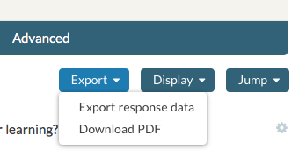
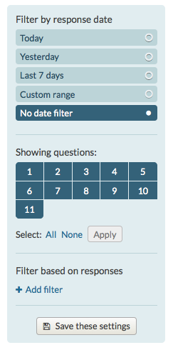
- You can also partition your data. That is, you can view the data for different groups of respondents as separate data sets for analysis. If you are downloading data into another system it may be easier to download the full set and partition your data in that system.
To partition your data in Jisc online surveys, use 'Filter based on responses' which is at the bottom of the blue panel on the left of your 'Analyse' screen. Click '+ Add filter’.

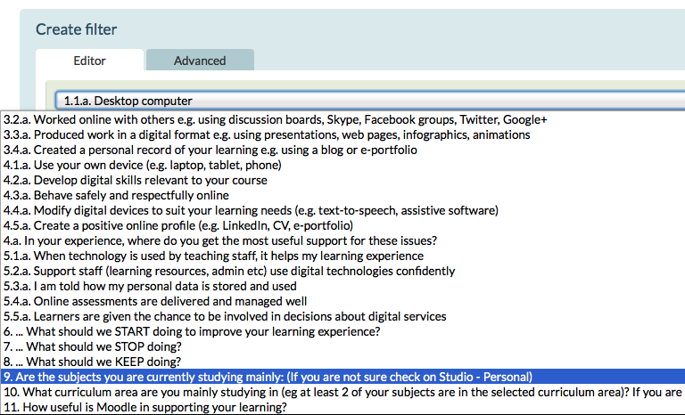
- You are now in the filter editor. Use the down arrow to scroll through the drop-down menu to the question you want to use for partitioning. This is likely to be one of questions 1-4 (in the student survey) or questions 1-3 (in the staff survey) (‘About you’) or question 28 (the ‘grouping’ question) in the student survey, which you customised precisely so that you could group your respondents at this point in the process.
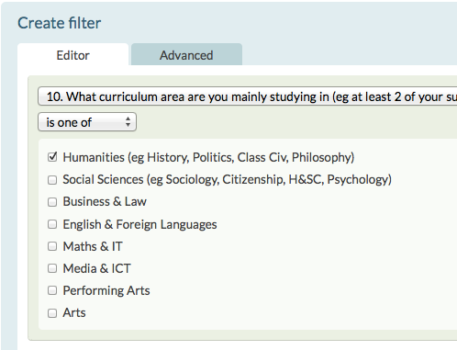
- Select the first of the options available under the question you have chosen. A tick box will appear. This indicates that you have set up a filter to extract all the sets of data where the respondent has given this particular answer. Click on 'Save and enable' and return to the 'Analyse' screen.
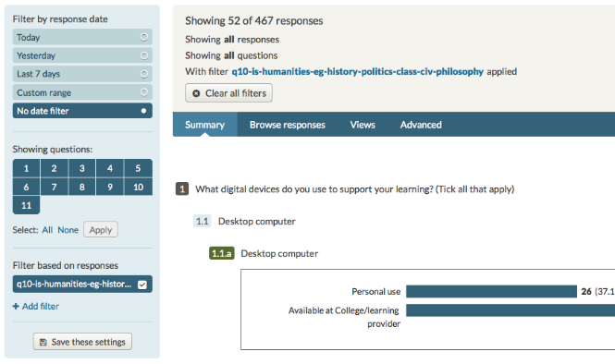
- In the blue panel you will see that you have set up and applied a filter. You can now view the data 'Summary' in Jisc online surveys or 'Download' the data for just this group of respondents. Repeat for all the possible responses (i.e. all the different groups of respondents) in this question. You can partition your data using other questions in the same way.
Note that when you log into Jisc online surveys you will be asked whether you want to view the filtered data that you last viewed or start afresh.
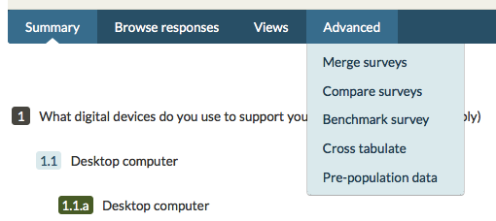
The option to benchmark your responses to a particular question is also available within the Jisc online surveys system. This means that you can compare your data with the average from other institutions using the Insight surveys.
From the 'Analyse' screen, click on 'Benchmark survey' in the 'Advanced' menu

- Choose 'Jisc benchmarking' as the comparison group from the drop-down menu and press ‘Select’.
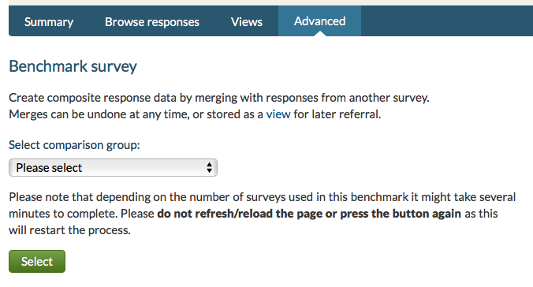

- Click on 'Benchmark' and wait for Jisc online surveys to calculate your comparative data. This can take a while, as there may be thousands of separate responses to calculate.
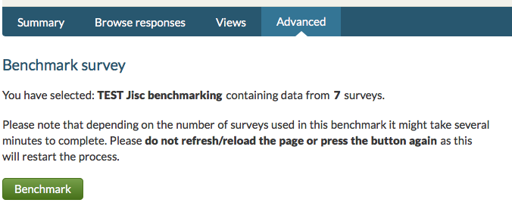
- For each question you will now see all the responses from your survey (column one) set alongside all the responses from respondents in your sector but not at your institution (column two), and finally both sets of data combined to give you the sector as a whole, including your survey (column three). This allows you to visually compare your data with the rest of your sector. (Note that these examples are based on a dummy survey with very little data).
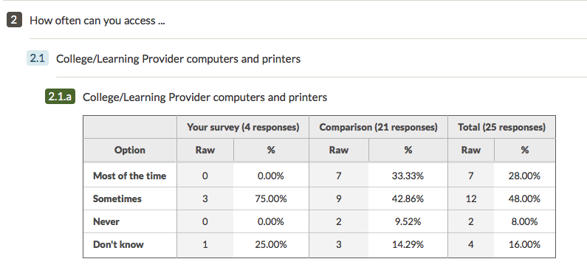
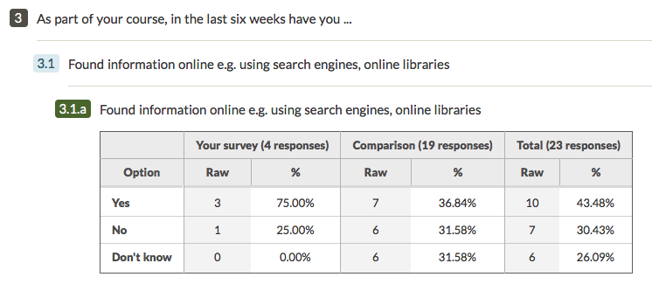
Comparisons are helpful but beware of making assumptions without checking whether any difference between two figures is statistically significant. To statistically compare your data with the benchmarking group, check out the information in our guide to Analysing and understanding your Insights survey data (http://bit.ly/DEIanalyse and also available from digitalinsights.jisc.ac.uk/our-service/advice-and-guidance).

If you need help
The Jisc online surveys ‘help and support’ pages are detailed and useful. Please make use of these resources first. If you do not find the help you need there, or if Jisc online surveys is not behaving as you expect from these guidance notes, please contact help@jisc.ac.uk (note please put ‘insight surveys’ in the title of the email to make sure it is promptly directed to the right team).
You may also get help and advice from other insight survey users on the jiscmail list jiscmail.ac.uk/JISC-DIGITALINSIGHTS-COP

