Customising your Insights surveys

What you need to know
This guide helps you to customise your Insight surveys to enable you to:
- Customise question 28 (page 12) of the student survey to allow you to group your institutional respondents in a way that makes sense to you (eg by broad subject area of study, by campus etc)
- Customise or delete question 27 (page 12) of the student survey or question 20 (page 11) of the staff survey which offers further questions or prompts on an ‘agree, neutral, disagree’ scale
- Add an alternative or additional question on page 12 (of the student survey) or page 11 (of the staff survey) if you feel confident to do so
- Customise text about any prize draw and ‘thank you’ message
If you are running more than one version of a specific Insight survey (eg further or higher education (FE or HE) and online) you will need to customise each version separately. However, we strongly advise you to make the same or equivalent customisations in each version so that you can compare your findings across the different respondent groups.

Before you start
Before you start customising your Insight survey we assume that you have accessed the relevant master Insight survey in Jisc online surveys copied it and saved it as a new survey. Consult our guide on using the Insight surveys in Jisc online surveys (http://bit.ly/usingDEI-JOS and also available from the digital experience insights website (digitalinsights.jisc.ac.uk/our-service/advice-and-guidance).

Important!
Questions can be edited using two controls in the right hand corner: a pencil control to edit, and a cog wheel to copy or delete the question. Always save your changes. No changes can be made once you have launched the survey so please save, preview, and test it after customising. You can always return to the ‘design’ view and make further edits. If you need more help with editing questions, please consult the Jisc online surveys guide: onlinesurveys.ac.uk/help-support

Customising pages
Page 12 (of the student survey) or page 11 (of the staff survey) are fully editable pages. When you have finished editing you must remember to delete the text in red using the cog wheel symbol.

Using question to partition (group) your responses
Question 28 (of the student survey) gives you an additional way of grouping your institutional respondents besides age, gender, and stage of study, which we have provided for you. Grouping allows you to analyse whether specific factors influence the responses that respondents tend to give. By default, we have suggested that you group your institutional respondents by curriculum area as this is a very common factor that institutions want to investigate. However, you can use this question as you wish. Note this question can also be used for the staff Insights survey to group staff by faculty or department, for example.
- You can delete it altogether.
- You can edit both the stem of the question and the answer options to suit the way curriculum areas are grouped and described in your organisation - or to investigate alternative groupings. If you are surveying a sub-population in a larger institution, you can use this question to create more precise sub-groups.
- You can also copy this question to introduce a second grouping factor (e.g. campus location) if you feel that both factors are likely to be important. Alternative/additional question stems could be:
  - What faculty are you based in?
  - On which campus are you mainly based?
  - What is your main mode of study? (e.g. campus-based, work-based...) (if student Insight survey)
  - What subject area do you mainly teach in? (if teaching staff Insight survey)
Once you have your question stem you need to edit the options within the question to specify the different groups.

Considerations for using the grouping question
Choose groups that are meaningful in your context. For example, you might want to reproduce groupings that are used in other surveys that you run or that reflect faculty or college structures.
Offer a maximum of four to five options in each grouping question unless you are confident of a very high response rate. The smaller the groups you divide institutional respondents into, the more likely it is that any differences between the groups are the result of chance rather than a real-world difference in their digital experience – and the less likely you will find any significant differences to report. You may have to group e.g. departments or faculties together to arrive at a manageable set of options. Do this to fit your organisational structures and to make sense to staff and students.
Define the answer options carefully and cover all the alternatives clearly. Avoid using an ‘other’ option if at all possible.
Don’t use grouping questions for the sake of it. Only group institutional respondents if (a) you have good reason to think that there will be a difference in these different groups’ experiences, and (b) you can do something meaningful about it, e.g. offer different recommendations to different subject area leads, or provide targeted support to particular groups of institutional respondents.

Using questions to investigate further issues
Question 27 (of the student survey) or question 20 (of the staff survey) are set out as grid questions in a similar style to many other questions in the Insight survey. It can be edited, deleted or copied to create another grid question. You also have the facility to add alternative or additional questions on this page if you are familiar enough with Jisc online surveys and with question design to do so with confidence.

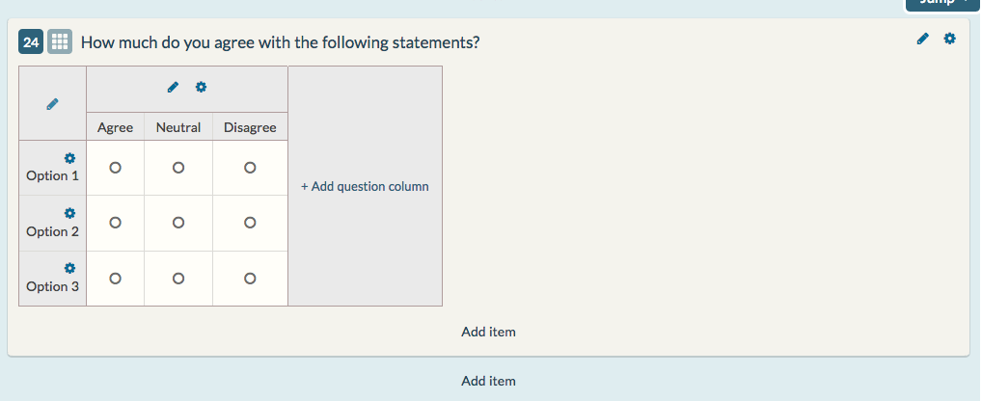

Considerations for using questions to investigate further issues and writing any alternative questions
- Use clear, respondent-facing language. Avoid jargon.
- Keep sub-questions or prompts short and limited to one idea, otherwise you will slow institutional respondents down as they think about what you mean, and it will be harder to interpret your findings.
- Clarify in the question stem how institutional respondents should answer the question (e.g. ‘how would you rate…?’ ‘how much do you agree…?’.
- Word statements positively so it is clear what it means to ‘agree’ or ‘disagree’. This does not mean your statements have to be positive about digital issues.
- Avoid leading statements and loaded language that point respondents towards a preferred answer.
- Test each statement to ensure that institutional respondents understand it in the way you intended. Ask a few respondents to work through the whole question, thinking aloud as they do so. Eliminate or rephrase any statements that cause confusion. You could also talk to these respondents more generally about the value of the questions you are asking. For example, are these issues important to them, and do they believe that any feedback they give will make a difference?
- If you are adding your own question(s), make sure you are confident about creating and editing different question types in Jisc online surveys. The respondents view of questions is very different to the design view – use the ‘preview’ button to review and always aim to test new questions with respondents before launching. For question authoring and editing consult the Jisc online surveys guide: onlinesurveys.ac.uk/help-support.
- Remember that asking open-ended (free text) questions will add considerably to the task of analysis.
- If you want to compare institutional respondents feedback over several iterations of the Insight survey you will need to ask about issues that will continue to be important. On the other hand, you may use this page to ask about issues that are very current, helping the Insight survey to seem more relevant to respondents’ immediate concerns. Bear in mind that if you do, respondents will expect a rapid response to their feedback.
- Remember that questions on this page can’t be benchmarked.
- For reasons of length, balance and participant commitment, there should be no more than three questions on this page (not including the final ‘thank you’ statement) and we strongly recommend that you use no more than five sub-question statements or prompts in any grid question.
- For reasons of length and balance we ask you to use no more than five question statements in a grid question, and if they refer to very different issues, please consider using fewer.

Customising the final page
You may want to edit the note on page 13 (of the student survey) or page 12 (of the staff survey) to thank institutional respondents for taking part. You could provide a more detailed explanation of how you will respond to their feedback and what value this will have to them. You might also add in a link of your own e.g. to the Insight survey project at your institution, or a hub for digital support. Lastly you could add a link to a prize draw (please see below). Note, please don’t add multiple links as respondents will not follow them.
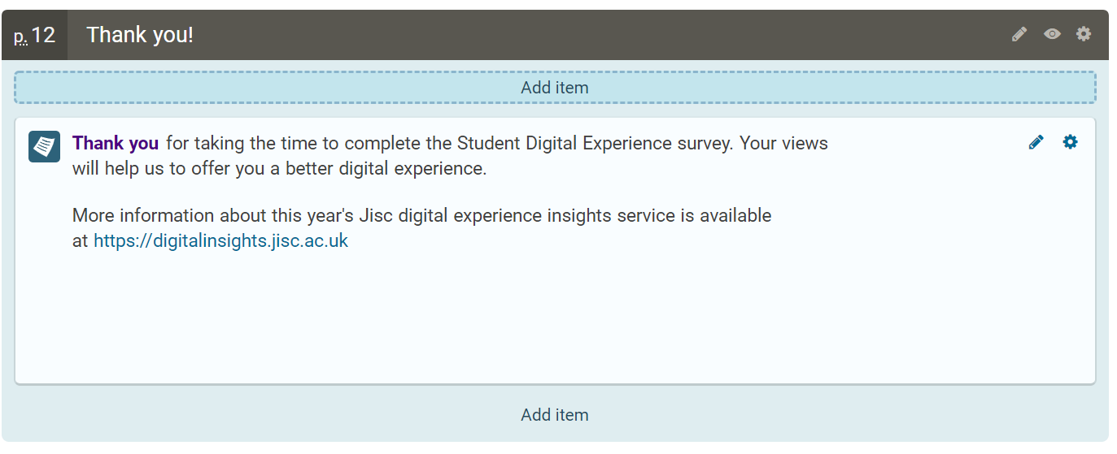

Setting up a survey for a prize draw

Why should I set up a second survey for a prize draw?
In previous years, some institutions have looked to encourage participation through a prize draw. It’s quite common to set up a question in a survey to collect a respondent’s email address so that they can be entered and contacted if they’re selected.
Although it might seem to make sense to add a question like this within the main survey itself, this presents a couple of issues:
- It will record the email address along with the rest of the survey data, meaning that the data cannot be analysed without also identifying individuals.
- To comply with data protection legislation, any identifying/personal data that is collected needs to be deleted one year after the survey closes. It is not possible to delete data from one question separately from the rest.
So, to ensure that data can be analysed with anonymity, and to ensure that your whole data set does not have to be deleted after one year, we suggest that you link to a second survey to collect a respondent’s email address.
The link will be placed on the page after the survey response has been submitted. So, only those who submit a response will be able to access it.

Step by step instructions for setting up your prize draw survey
- In addition to the Insights surveys that have been shared with you, you will also find a template named ‘MASTER - Prize draw.’ Make a copy of this template in the same way as you did with your Insights survey(s).
- This template is not locked and can be edited as you see fit, although we have styled it to look similar to the Insights surveys and recommend that you do not change it too much. For example, perhaps you could edit the note to be specific about what the prize draw is for. You can launch it as it is if you prefer.
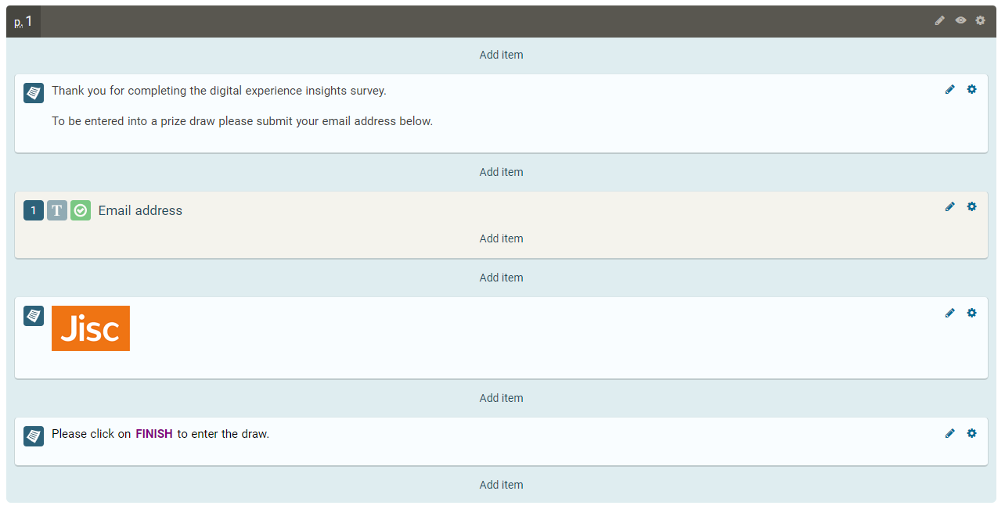
- Once you have edited and launched the survey, find the survey’s public URL on the Survey Launchpad. Right-click the link and copy the address.
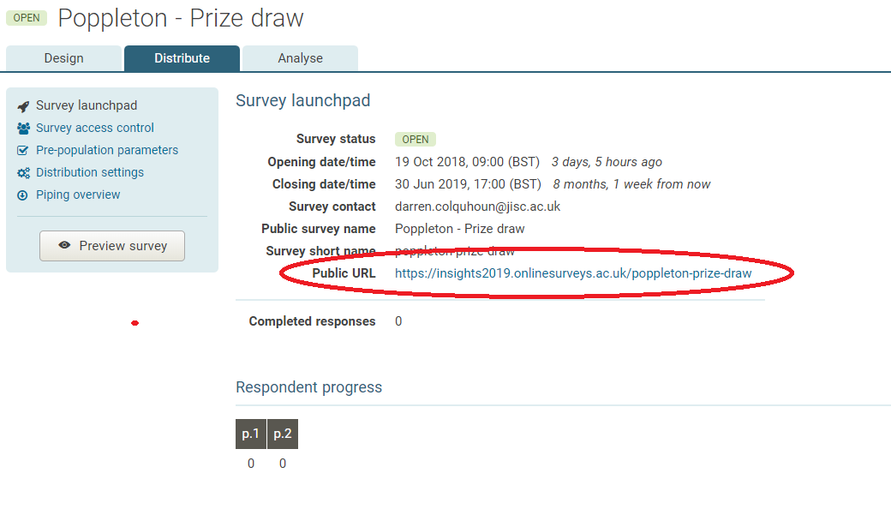
- Go back to your Insights survey, and on the final/Thank you page click the pencil icon to edit the note.
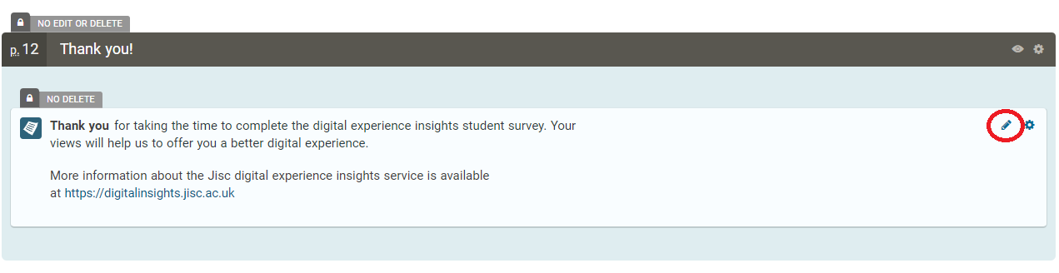
- Add text to the note that will serve as a link to your prize draw survey.
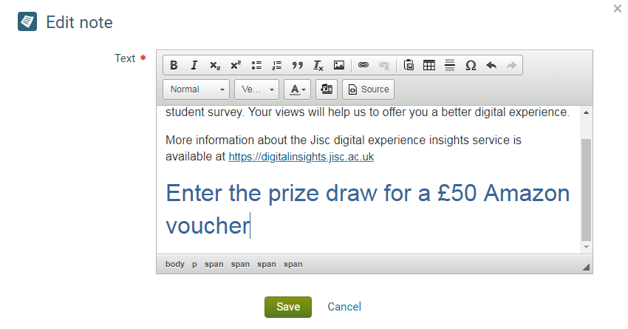

- Select your new text and click the Link button in the note editor menu.
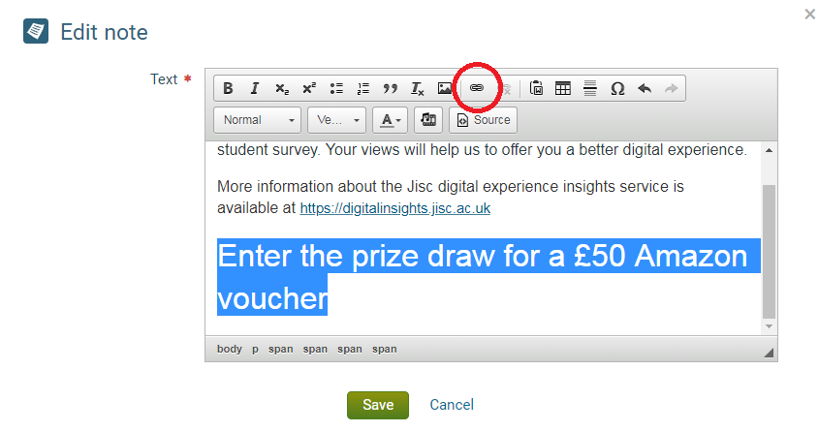
- Paste the public URL you copied from your prize draw survey into the URL field on the link editor and click OK.
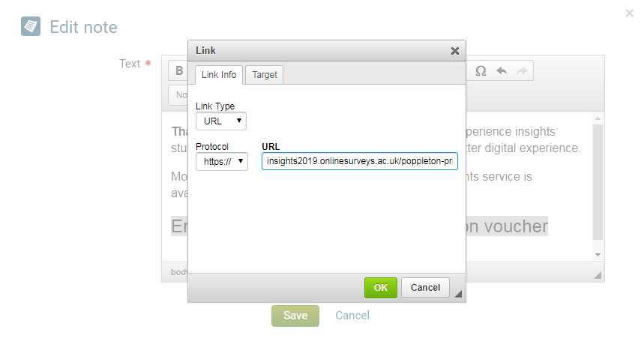

- Click Save in the note editor.
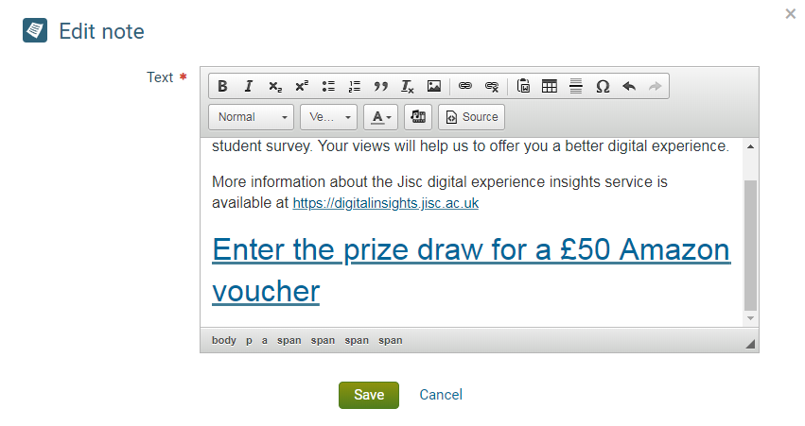
- Preview your survey to test the link works.
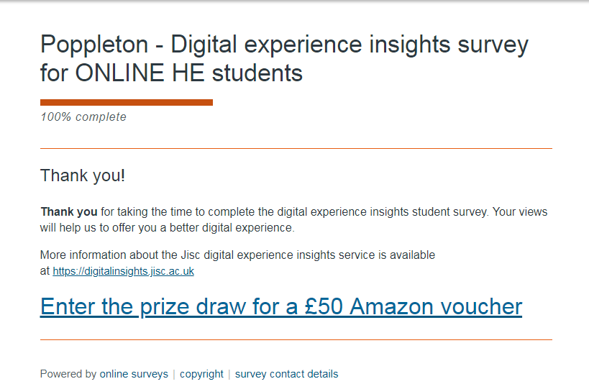

Some things to remember
- The link must go on the last page of the survey (the Thank you page) and not the optional page for your institutional questions. If the link is placed on the institutional questions page, the respondent will be navigated away from the Insights survey before submitting their response.
- Once you have drawn a winner, make sure you delete your Prize Draw survey.

Our guides
Visit our advice and guidance section on the digital experience insights website (digitalinsights.jisc.ac.uk/our-service/advice-and-guidance) to view our full set of guides to help you successfully use the digital experience insights service.

Your decisions
Use this table to note down your decisions before customising your survey(s) on Jisc online surveys

Grouping question(s) on page 12 (of student survey) (stem and options):

Grid question(s) on page 12 (of student survey) or page 11 (of the staff survey) (if used – stem and options):

Any additional question(s) on page 12 (of student survey) or page 11 (of the staff survey)

Thank you text on page 13 (of student survey) or page 12 (of the staff survey) with any links:

