Our six-step guide to launch your surveys in under an hour
Digital experience insights service

Step 1: log into your Jisc online surveys account and look at the master insights survey(s)
- Log to the Jisc online surveys page
- Enter your email address and password and sign in
- If you’ve mislaid your login details, just click on 'lost invitation' to trigger a new one
- Once signed-in you select the relevant insight survey account from the drop-down menu at the top (see area circled in red in screenshot below). The accounts are named:
  - ‘Digital Experience Insights 2019-2020’ - to find student insights surveys
  - ‘Staff Digital Experience Insights 2019-2020’ - to find teaching and professional services staff insightssurveys
- You will also need to ensure that the box ‘JUST MY SURVEYS’ is unchecked so that you can see the master survey(s) you have requested (see area circled in red in screenshot below)
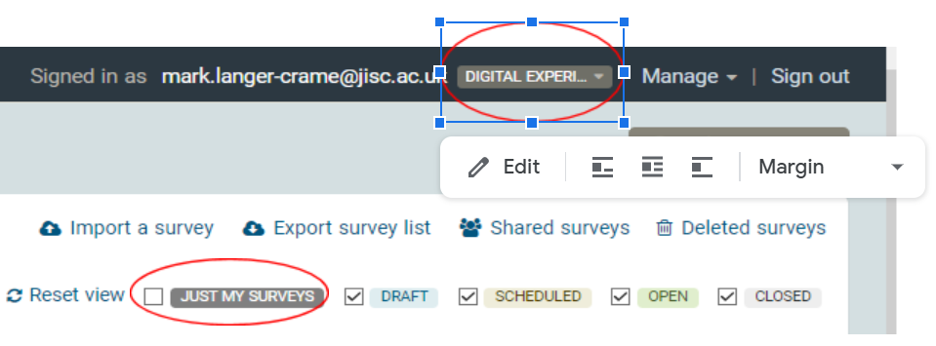
Screenshot 1: how to find your surveys in Jisc online surveys dashboard

Step 2: copy from the master survey(s)
- You will now see the master copies of the survey(s) you requested in the screen now
- Take a copy of these using the purple 'copy' icon on the dashboard (see area circled in red in screenshot below)
Screenshot 2: copy icon on Jisc online surveys dashboard
- Name your insight survey: [name of your institution] [HE/FE/HE online student and/or teaching staff/professional services staff] [2019/20] [insight survey]
- If you’re using the Welsh version, please indicate either by putting the title in Welsh or adding '(Welsh)' to the title
Our guide on using insights surveys in Jisc online surveys offers more information on how to copy your master survey(s).

Step 3: customise your survey questions
A small number of questions can be edited although we need most questions to be identical, so that we can group everyone’s data and share this with you all. This allows you to compare your organisation's data against the UK sector data as a whole in the benchmark. However, you can make the following edits:
- Customise question 37 of the student survey, question 34 of the teaching staff survey or question 28 of the professional services staff survey to allow you to group your organisational respondents in a way that makes sense to you (eg by broad subject area of study or teaching, location of role, or by campus etc)
- Customise or delete question 36 of the student survey, question 33 of the teaching staff survey or question 27 of the professional services staff survey which offers further questions or prompts on an ‘agree, neutral, disagree’ scale
- Add an alternative or additional question on page 10 of the student or teaching staff surveys or page 9 of the professional services staff survey if you feel confident to do so
- Customise text about any prize draw and ‘thank you’ message.
Our guide on customising your insights survey contains more information.

Step 4: check the survey(s) before you launch!
- Once you press launch you can’t edit the survey, so make sure you check it carefully first
- You can create and share a pdf of the survey by going to 'Preview Survey' under the ‘Design’ tab and clicking on the cog in the top right of the screen, then clicking on ‘Export survey as PDF’ (see area circled in red in screenshot below)
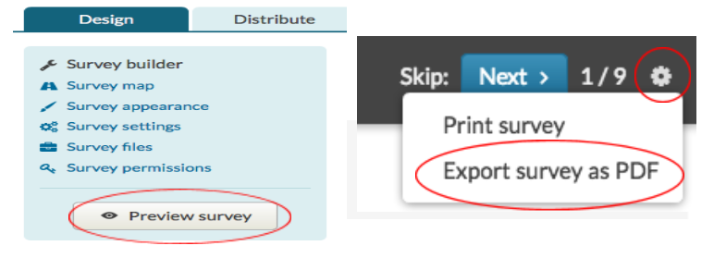
Screenshot 3: preview and export options in Jisc online surveys dashboard

Step 5: launch your survey(s)
- From the dashboard click on 'distribute'
- Check that you are happy with 'public URL' link address (if not you can change it under 'distribution settings' as indicated by red circle in screenshot below)
- You can also change the close date here if you wish to
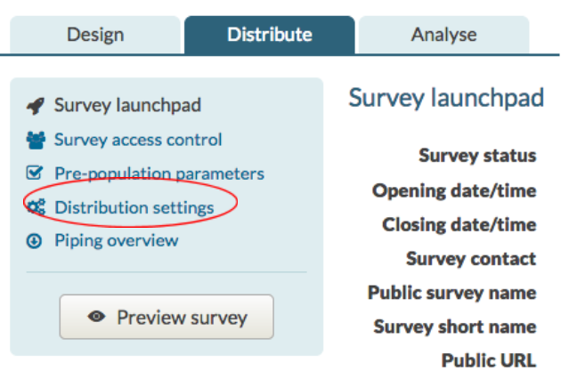
Screenshot 4: distribution settings option on survey dashboard for Jisc online surveys
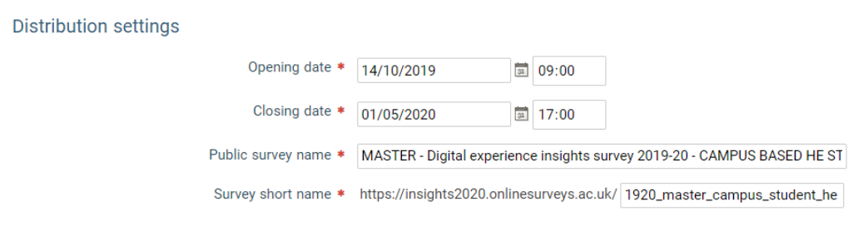
Screenshot 5: opening/closing date and survey URL naming section of distribution settings in Jisc online surveys dashboard
- Make sure your surveys are exactly as you want them; your settings are correct, and your communication channels are ready to go before you click the 'Launch survey' button. To do this, just click on ‘survey launchpad’ option, under the ‘distribute’ tab and then click on the green ‘survey launch’ button (see areas circled in red in screenshots below).
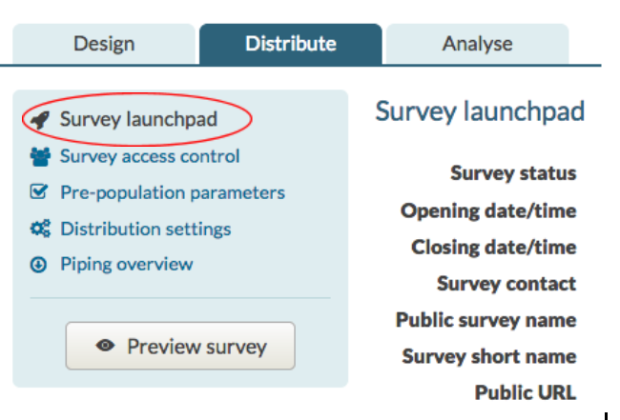
Screenshot 6: survey launchpad option within distribution settings tab in Jisc online surveys dashboard
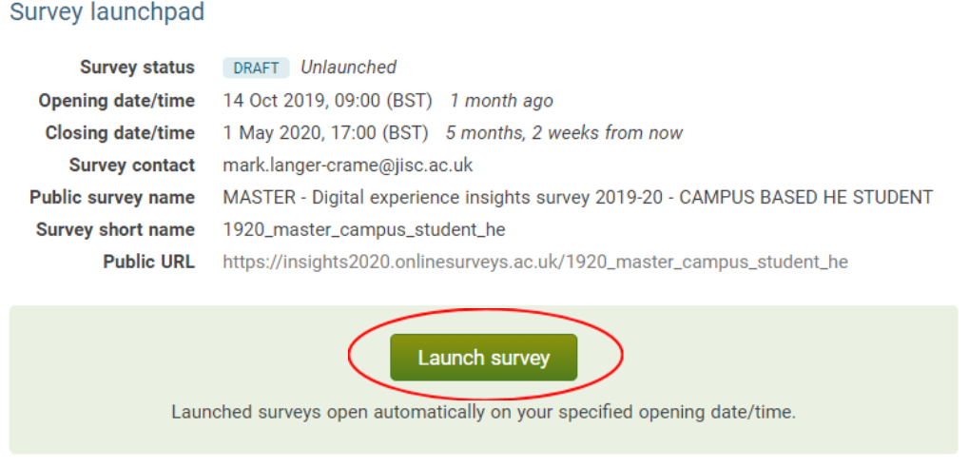
Screenshot 7: Launch survey option on Jisc online surveys dashboard
Our guide on using insights surveys in Jisc online surveys contains more information on how to launch your survey(s).

Step 6: engage your students and staff
Engagement strategies include:
- Sharing the public url link with your students eg in lectures, on twitter, via the student union, via their tutors
- Running your survey as part of focused initiative such as a 'digital student' month
- Using table top adverts or screen tray inserts in café and canteen areas
- Using posters, social media and digital screens to share initial findings while the survey(s) are still live
Our guide on engaging respondents in your insights surveys offers more suggestions and guidance and you will find templates for posters and sharing findings on our resources page.

Our full set of guides to support your use of digital experience insights service is available at digitalinsights.jisc.ac.uk

